ASP.NET Core MVC Request Life cycle:

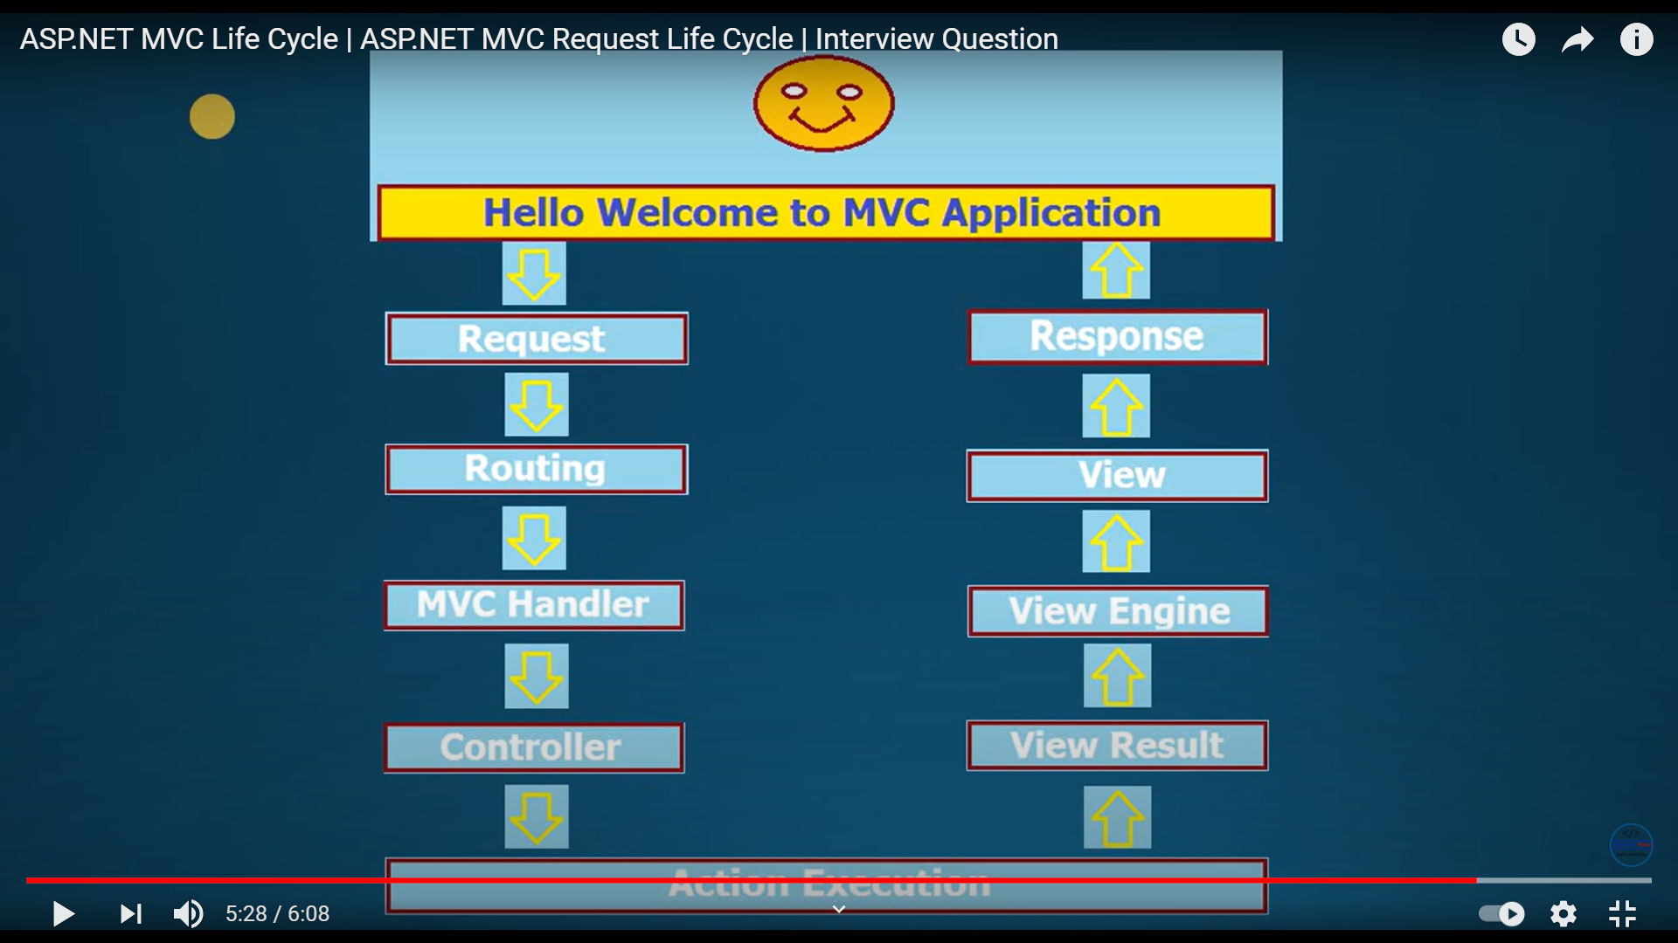

Routing:

1. Conventional routing
2. 2. Attribute routing
3. Attribute Routing in ASP NET Core MVC

<https://www.youtube.com/watch?v=prNptonJAiY>

# ASP.NET Core MVC Request Life Cycle

<https://www.c-sharpcorner.com/article/asp-net-core-mvc-request-life-cycle/>

# Learn How to Build an Angular Application With ASP.NET Web API Core, Create a Docker Image, and Run Using Docker Container Services

<https://www.c-sharpcorner.com/article/learn-how-to-build-angular9-application-with-asp-net-web-api-core-and-deploying/>